12/18/2023

Alright I’m updating and the movie list has gotten so big that I cannot tell where I am in the list. SO I need to make a search bar. I have to go to the library to get some info from fb to finish updating theno inspiration posts and I scheduled a Live for tommorrwo as well…after that then it’s updating this movie list.

12/12/2023

A little annoying. I have to save the picture here so that I can keep track of them…

To position an image within a `<div>` element so that the entire image is visible, you can use CSS to control the positioning and dimensions of the image. Here's an example:

HTML:

```html

<div class="image-container">

<img src="your-image.jpg" alt="Your Image">

</div>

```

CSS:

```css

.image-container {

width: 300px; /* Adjust the width of the container to your desired value */

height: 200px; /* Adjust the height of the container to your desired value */

overflow: hidden; /* Ensures the image doesn't overflow the container */

position: relative; /* Required for absolute positioning of the image */

}

.image-container img {

position: absolute;

top: 50%;

left: 50%;

transform: translate(-50%, -50%);

max-width: 100%;

max-height: 100%;

}

```

In this example, the `<div>` element with the class `image-container` acts as the container for the image. Adjust the `width` and `height` properties of the container to your desired dimensions.

The CSS rule `overflow: hidden;` ensures that the image doesn't overflow the container, hiding any excess.

The `<img>` element is positioned absolutely within the container using the CSS properties `position: absolute;`, `top: 50%;`, and `left: 50%;`. The `transform: translate(-50%, -50%);` rule centers the image both horizontally and vertically within the container.

The `max-width: 100%;` and `max-height: 100%;` properties ensure that the image scales proportionally to fit within the container while maintaining its original aspect ratio.

Make sure to replace `"your-image.jpg"` with the actual path to your image file.

With these CSS rules, the image will be positioned and scaled within the `<div>` container, allowing the whole image to be visible while maintaining its aspect ratio.

one

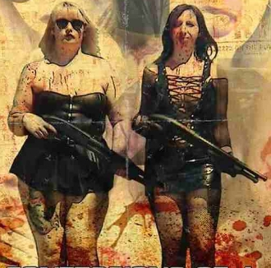

Two

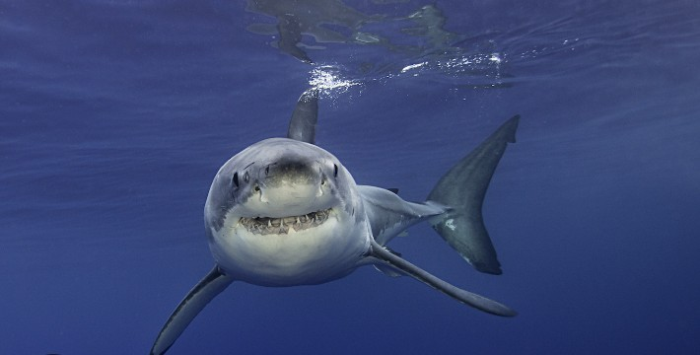

Three

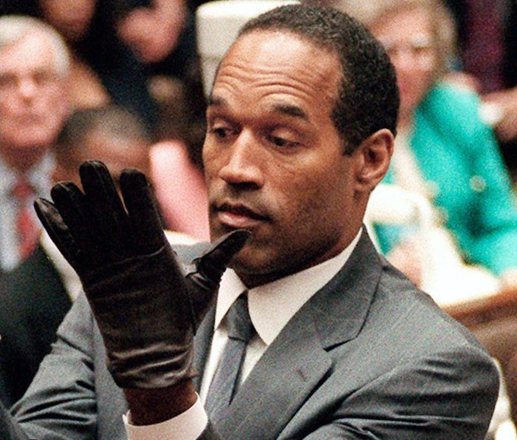

Four

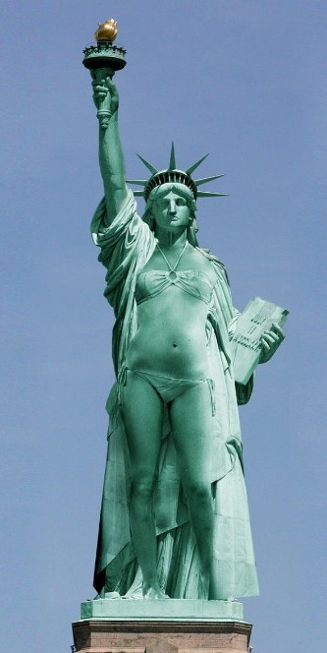

Five

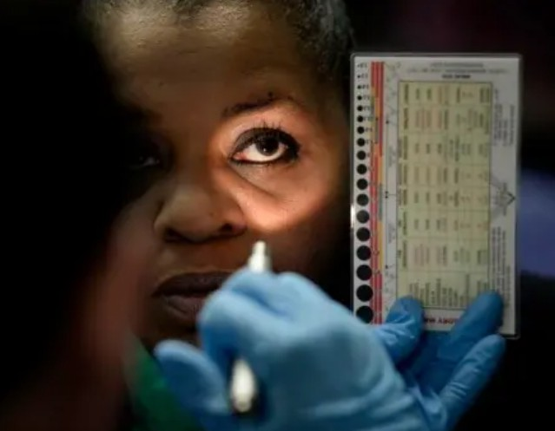

Six



Seven



Eight

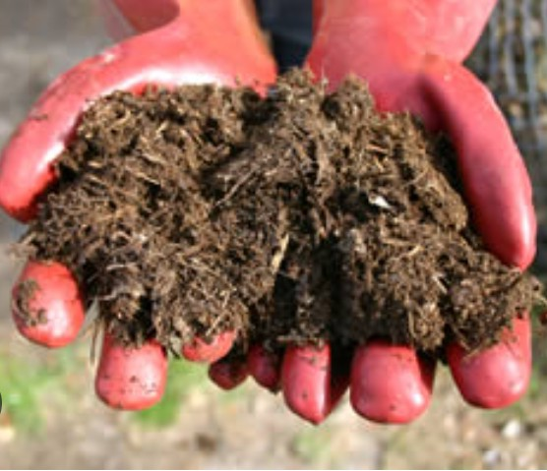

Nine

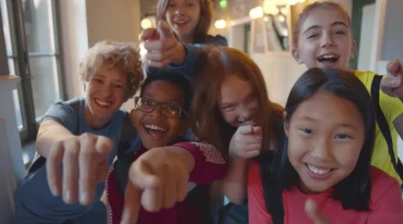

Ten



Eleven

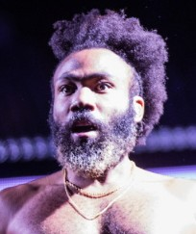

Twelve

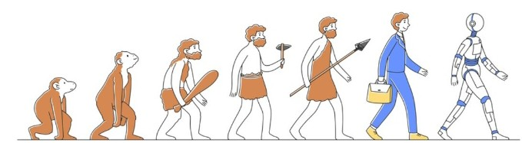

Thirteen

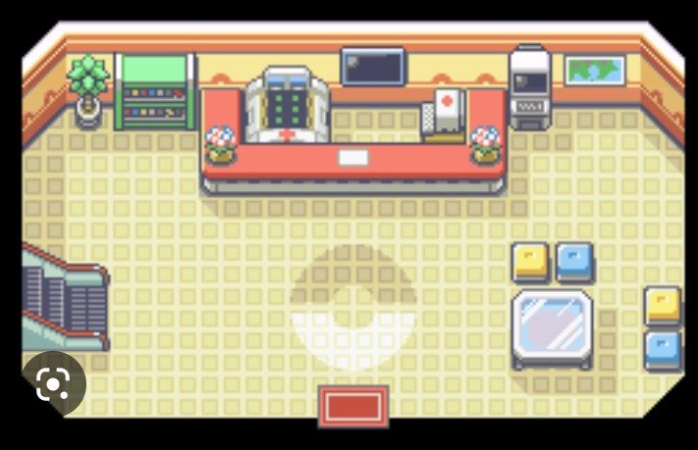

Fourteen

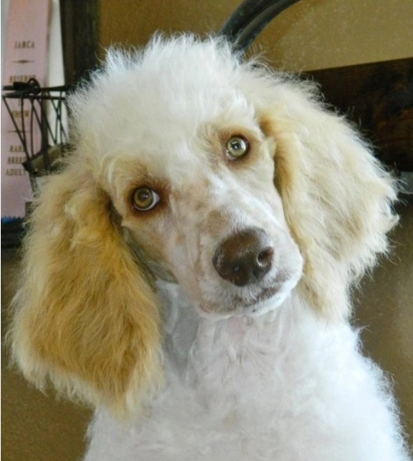

Fifteen

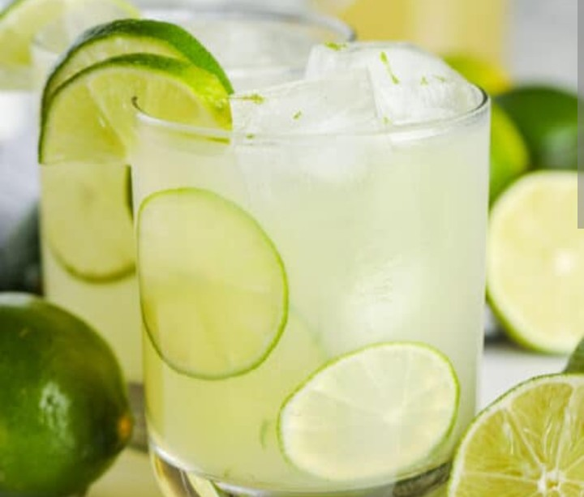

Sixteen

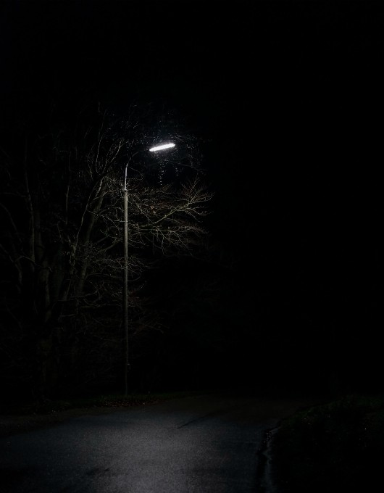

Seventeen

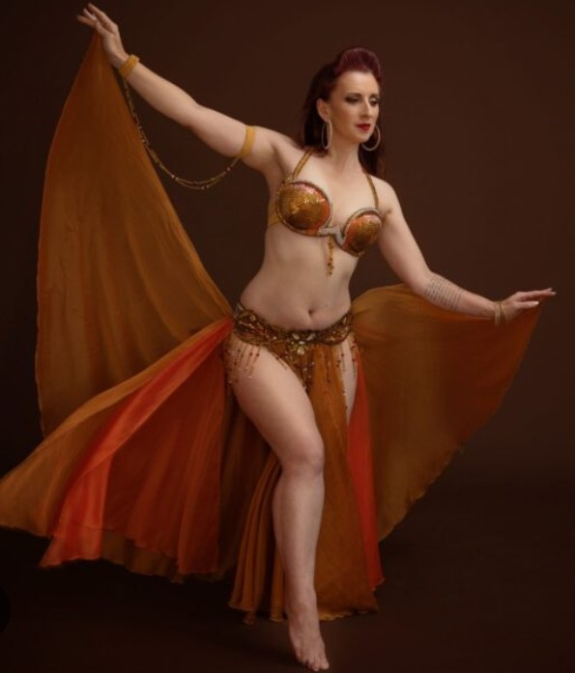

Eighteen

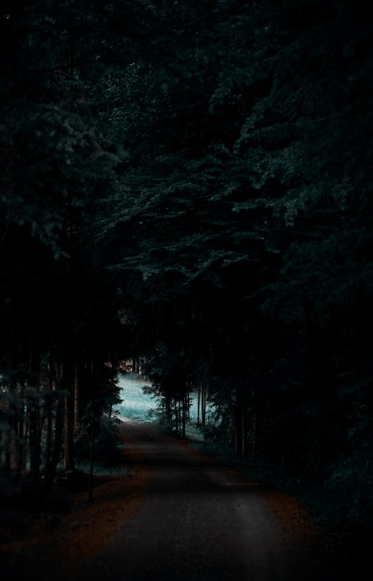

19

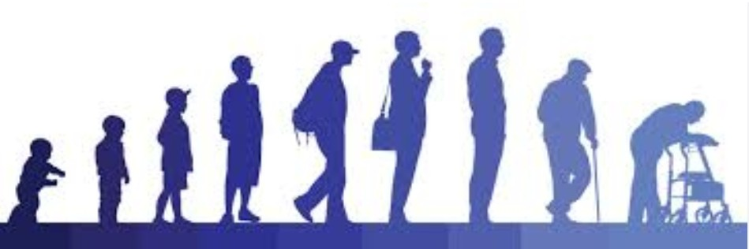

20

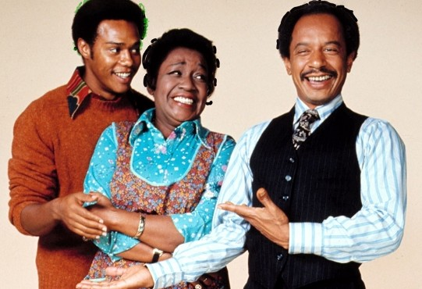

21



**22**

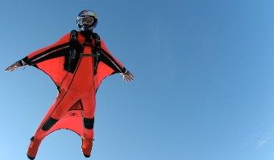

**24**

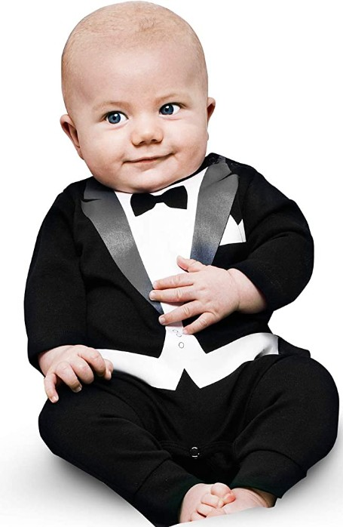

**25**

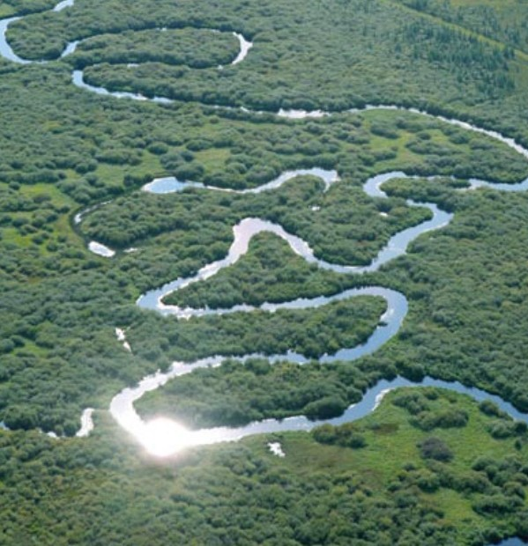

**26**

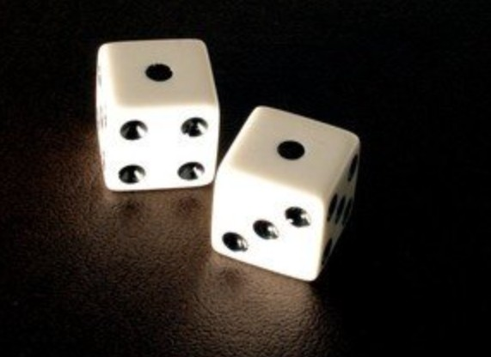

**27**

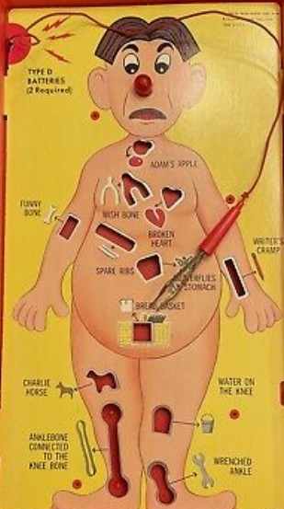

**28**



**29**

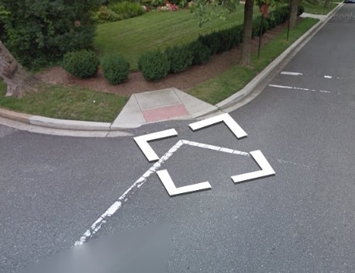

**30**

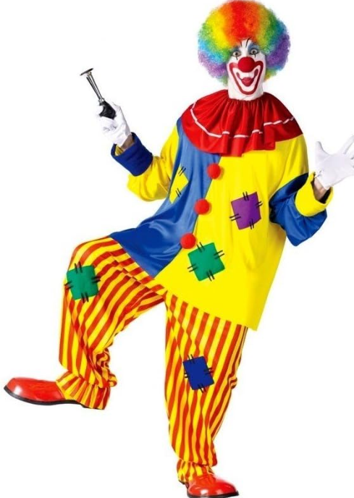

**31**



**32**

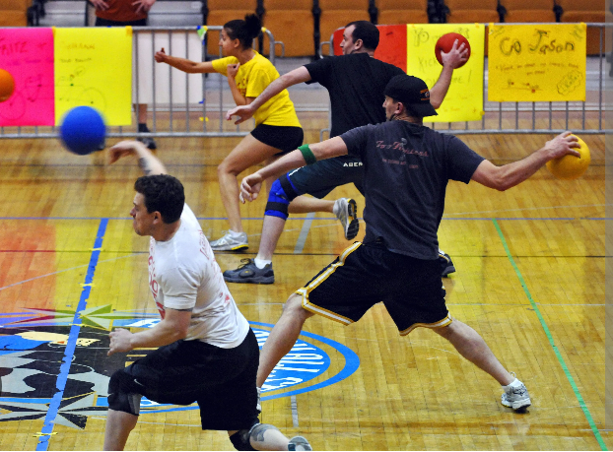

**33**



**34**

**35**

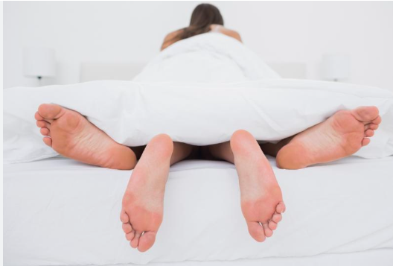

**36**

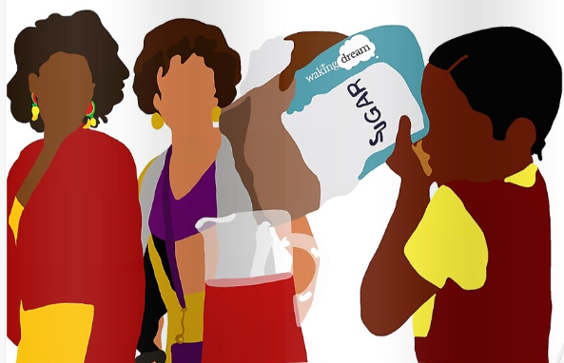

11/27/2023

Been a while longer than I hope. But I’m working on adding the posters. I need to position the button element [properly, then it is suppose to become a bigger image with the name and purchase option in the div I already created for it.

11/13/2023

Not sure what happened below with the date. But I worked today. I left off at designing the shop section. Working on an unorder list.

11/20/2023

Clocking in.

Alright. This session was me finishing adding in the designs to a few facemask templates. I still haven’t really considered the design of the shop. That might be the mission for next time, but also there are other products. Like buttons, stickers, and greeting cards, and posters.

10/24/2023

Back at it. Formatting is good. Of course I have to uhh see what it looks like on the phone. That’as always a different thing.

So there are a lot of refining and tweaking below. I know I want ot add in the word count to the bouBlogs. I don’t want to work on these now. I want to start planning for moving forward. So page 5.

Cool. So the next step is to starting thinking about htat. I’ll sart that next tie I work but first I just have to compile a todo list so I don’t have to scroll.

10/22/2023

Great. I have the videos and audio active on the proper page. The formatting is a bit off, but I’ll work on that next time.

10/19/2023

Raps are updated so I have finished this update. Everything that I’ve added since stating that I need to work on updating the pourboy label is for after I finish with the label. So that is what I will be workingon until my next update uhh on 11/01.

Alright. I have finished updating the new no inspiration posts. It needs some chiseling. Three things. I need to make all the images the same size. That will affect the text. And I need to make sure the back button is well positioned. ( there are some places where the picture size pushes the link down, and I need to increase the top margin a bit.

10/17/2023

Back at it

10/16/2023

Alright. Working on collecting the quotes so I can add them.

I’m looking at the noinspiration quotes and I want to add a button that reverses trhe order so that the last plays first and so on. I do like The regular order so I don’t want to change that. Also I need to look at the font colors again.

Alright. Break time. I finished one image. I have like 6 more.

10/15/2023

Cool just finished the blog. Next is the inspiration quotes.

Cool so the entire movie page is up to date. But I have more planned for it. I want to have a list of all the movies, and then the ability to search by genra. Also For anything that is a series I want to have the series pop up probably on a hover or something. Now this part I’m not sold on by it’s an idea; I want to have the budget and the box office and a rating system. I should probably throw that in. But that’s not what I’m working on now.

Next I’m going to tackle the blogs. Also I’ve got to do a scan trough fb I think I might have a rhyme and a play to add as well.

Alright the movie section should be god to go along with the arrow add on. I have to update the books the same way I did the movies.

After that I have to add the blogs and add the new no inspiration quotes.

10/13/2023

Alright the movies have been updated. Now I need to update the books section. Also because I don’t mind the thumbnail problem so much, I need to add in the title at the bottom of the p area.

10/12/2023

Alright. I just finished updating my last two lives. I’ve decided that I’ll be updating the boutique all day. Or until I finish. So that’s another blog and a big movie page update.

09/29/2023

I started adding in the new live review to the website I still need to finish it. I think it’s the JS remaining. I also scheduled my next review for tomorrow.

Alright. I’m working on updating. The list update the new blog, update the new live review. Update quotes. Update Movies.

I thought I updated this yesterday. I probably forgot to save. Note that I need to update All of the Boys stylewise, and also add in the video and audio and include the spotify playlists.

08/18/2023

Well. Ads are not working for a while longer. There’s a list of things that I’d have to do because apparently it’s not ad ready. I’m a bit to even add that to the list right now. But it’s a goal for the future.

I guess outside of that I can tackle the effect I wanted for all of the boys. The idea is that There are secret triggers the first one is on the middle of the page and hovering over that reveal a few more (I haven’t really considered positioning but it could be five or six in a diamond position).

See I like this idea. I was even going to turn the cursor into a penis, but how pertinent is this design to something that visually act like a museum. I think it’s a bit to much.

What if…I frame the photo’s and then design a bit of text or a video montage that can show if a button is clicked. Essencially after the click, the photo is revered to the back the frame disappears and there’s the vid or text.

Now what if I combine both the ideas. And all the triggers could be different color from the background.

The problem coming to mind is the phone use. Naturally a media query would help, but I have so very little experience with those.

So I want the diamond position (I’m not sure how many filling out the inside of that position), but then instead I want landscape mode on the phone where 3 options are presented, the click pulls up the text or vid or whatever, and dbl click changes the option randomly.

Also I’ll note that I guess a few pages need some aesthetic help, but two pages aren’t even functional. Moving forward unless I’m updating material, it’s all going to be new stuff, stuff that I don’t have much experience with in a way, so maybe we’re reaching that point where it’s time to look at the music vids playlists and the label videos. But I’ll take care of all of the boys first.

08/14/2023

Ads haven’t starte working yet.

I was thinking about a warning label to get people to use the computer. Of course I will get better at designing for the phone and computer, just for now.

I have a bit more material to add from the fb page but specifically I have a new review to add.

The back button on the graphic design page link in wrong.

Outside of tweaking these issues progressing would be wither developing the 5th floor or …I feel like I had another option that now I cannot remember. But yeah, I can either tackle the things on this list or develop the fifth floor.

08/02/2023

Increase the width of the photos

The home button is not visible on the mobile website (08/14 this is specifically for page 4)

There’s user experience that I was thinking about for all of the boys; I want to have them pop up in different spots and to turn the cursor into a penis.

I guess I just decided to make ads my next objective;

I just finished adding ads. It’ll take an hour for them to show.

07/25/2023

Adding formatting the bouBlogs to the list of things to do.

I have to develop the a label pourboy.

I have to add ads.

**I have to develop page 5 starting with FAQ and then leading to the giftshop and backroom .**

07/21/2023

Alright…I just have a few more things to manage before I end this update. I need to fix the font color to something more visible. I need to fix the door. And I want to save my last floor direction to facebook. I also need to fix the car picture and move that one picture to graphic design.

07/13/2023

I’m working on grabbing the information from the webpage. I’m just added the movies. There’s still more work to do there.

06/03/2023

It’s been a while since my last update but I really just haven’t updated. But I’ve been ona bit of a break the last week. To pick it back up where I left off, I have to finish the no inspiration posts, add in the new blog (I’m also due for another one), and add in the new 2 second play. Also I have mp3’s of those songs for reference.

05/10/2023

Okay So I just updated my phone number…it could be a good idea to get rid of the removal of the email. I added in the next blog. And updated the cashapp. So in terms of updating a big weekly update or something might be important. I don’t actually know how far back to go in social media and I don’t want to find out. Updating list is still the fifth floor. I’ve also been reatching out for ads. So there’s that.

For debugging I have to watch that vid still.

05/04/2023

Right, so apparently there is a way to connect my phone to the the computer to use dev tools to code. However it’s not registering my phone…the computer is not. Also Since I know nothing about dev tools there is a tutorial I’ll take this time to study.

Debugging List:

No Inspiration Section

The Label Pourboy Section

Update List:

I need to add my email to the index page. I’m thinking it can be a hover over the img element. Also a message that says PC is the best way to expeience the site.

I need to update the last pic on the photo book section

Mabye it’s not important now….but it probably is the best time to do it, but I need a better system of updating. Or rather consolidating some form of information so that I don’t lose tractk updating…Maybe a daily update is key here…

05/02/2023

Debugging list

Changing the image size in the no inspiration section is thougher now. This latest update included everything in my lastest pushed cleared, but when it comes to positioning these images perfectly, it makes me with I left it alone. It’s hard because the positioning/formatting on the computer and phone have a habit of being different. Again on the computer it looks perf…I don’t know…if I could bet on my pushing clearing that would be one thing…but right now I might have ot leave it as is.

The first image on the weed page lost it’s hover capability. It has the class. I had an inline element that I just removed. Well see how it looks when I update.

I think in terms of debugging…I will wait until I finish my second course on udemy before I move toward debugging again. The problem is the phone updaes, and with positioning issues it’s impossible to challenge.

Update list

Updating the fourth floor…So I just realized that I haven’t assed a books section. I want to have a div that displays on button click. The idea and Id should be explained that movies are moving pictures. And A good book to me always reads like a moving picture. It’s magic like that.

04/29/2023

I haven’t updated by I’ve been at it. I’ve been pushing to github and it’s been challenging. To properly debug I need to see what it looks like on the phone and first I’m having issues with github rendering. I do get it to work and I’ve updated a lot of things. I’m not sure how to completely navigate git like is it my cache or is this update the github appearance (like I just did and it worked) the solution. But I managed to finally update it and im going to move forward. I’m sure I’ll git working predictably at somepoint. The other realization is that I have to keep a list of what I need to debug. The website is pretty much up and I’m happy with it now. I’m not quite working on version 3 (which is product based) but just maintain an environment where what I add to social media is also updated on the site. So I’ll be splitting my time working on the boutique between debugging and updating. The github issue is going to slow me down for now but I’ll only be putting in an hour to an hour and a half for each. I’m working on getting my udemy courses back and if that works I’ll be back working in some skill growth in to my schedule. Looking at the full stack direction it seems that python , sql (which I’m doing another round in online) and django (the only one I don’t have experience with) are important points.

Debugging list

I need to set all of the images in the no inspiration quotes to the same size, just be warned that it will affect the font-size, so it’s a task.

I’ve done a lot of work trying to get the bouBlogs to show, and it didn’t show in this latest rendering from github, but the url was incorrect so I guess I have to wait until the next time. I’ve already corrected it. -complete

I’m going to leave it alone for now ,but there’s spillover in the first image of the weed document. I won’t leave it alone, that image is bigger, but all of the img are set to the same size…I just went through and added th e styling inline…we’ll see what that does. Also I didn’t add the proper img class to the element…just did…Well maybe it’s the special note, because on the computer when I hover it spills out and the others don’t do that. It’s not spilled out on the computer but it is on the phone like default. I think it’ the screen size. The element are set to space between on the computers fullest screen there is no spill. I thnk I might just accept this for now.

The label pourboys section needs all the help in the world. The content is not set to play.

Work list

Updating the material on floor 4

Floor five is special I already mentioned that it’s a section where I maybe go a bit more indepth on my personal fb posts. That will also house the contact list app. I’ve been thinking a lot about ads. I don’t even want to put a back button on some pages. However floor five I think is a more commercial page. I forget to include the faq page. It’s not super important until the products start but maybe floor five is a good place for it.

04/26/2023

Alright. This has been the worst coding s ession of this update. I had to stop and leave messages saying the page is not ready. I have little experience with video and audio. I know I have that udemy course or two . I’ll finish them and see where I am in life. I ideal is to be in a course. Of course I have no problem updating it as is for this update. Moving on there is the final active section of this update. All of the boys music videos and movie posters. I know the movie posters will get a blurb on why I shout it out. The music videos will also include my spotify playlists. I guess it only feel right that all of the boys gets the same treatment as the movie poster.

04/25/2023

Alright the coding session for this page was stopped. I have to keep going onto the audio. I have no idea how to add the video and I’m having conversion issues. I think I have enough study material to say maybe by the 2nd or 3rd update it’ll be up but not right now. Also the problem is that it’s age restricted on youtube, so I can’t exactly use Iframe. I’ll put a place holder and move on to the audio tomorrow.,

Alright. I’ve reached the Label PourBoy section. I don’t know why but I don’t really know how to proceed here. I think I decided to add the playlists to the music video section on floor 4. Uhh also doubling the mp3 rhymes in the rhyme section and the label section as well. So apart from those this section is for…wellI think the problem is that this section is not so well defined. It’s a production company..but the whole thing is a production company, so the difference is…it’s not literature, photography, (I guess a help question could be once talisman is complete would it go under the label pourboy)I want to say it’s not graphic design. I guess I should make those separate products for a fact now.

The way the website is designed is lit, photos, media…then the media section is broken up into bits. I think the label pourboy is move personal and creative media. It’s not a record label because I already have a section for my favorite music. So yes this is where talisman and the uocoming metamorphosis project will go.

The material for this section is

the two version of say a yiyi

the manLib project (that may have a video component)

and tow recordings on google drive *sorrydrake and

04/21/2023

Alright the work has been pretty good so far. I’m up to the graphic design section. Images are already saved and ready for uploading. I do have a few audio tracks? I have access to the audio project but not the course. There’s some javascript involved with audio…We’re making good time.

04/21/2023

Alright I’m woring on the quote section and I deceided to turn them into real quote with images. I already have images and I just need to ad the text center. I plan to use button s to switch to the next image. And maybe add a transition…

04/20/2023

Alright the second session has gone well. The nic cannon is complete and the design is there. I just finished adding in the text for the next one. I’ll have to finish working it in tomorrow.

Well another day another dollar. I‘m working on the live commentary section and I just want to mention the idea I’mm working with. I can’t really code it now because the text was already posted on FB but moving forward,…right now I have the links changing color between red and blue. Should I lock one of these live commentaries I want the color to change to white. The color by default is black then hover red or blue locked is white then as the mouse moves down I want it to reveal (by changing hover from white to black) the text that says hey unlock this-throw in a quarter etc. Well I just realized that I like to do these in public and live encouraging people to comment in live time etc…That could mean deleting? If I decided to monotize it?

04/19/2023

SO I realized that I have to do two seesion of code to get this done in time. I pretty much finished the weed blog. Next is whatever is the next link.

Right so a good stopping point for now. I’m working on the weed grow project and I’m trying to align the images with text. It’s coming together, but ther are a few thinks I don’t want ot forget. I need to put the special not on the container in a button and the about his project ui needs a couple fun images. That’s it. There’s the end ui will have it’s own design.

04/18/2023

Cool so I’d say the bones are laid out for me to move onto the next step of adding the meat. I have to go online and get the infor for floor one from facebook. I’ll do that today and probably update tomorrow.

04/17/2023

Okay so the task is to list the products getting ready for the museum section

So the platforms I’m using are youtube, facebook (profile and page), instagram

I’ll be checking everything except instagram since…well I’ll list it…maybe there can be a home for it on the museum tree

* Instagram:
  + - ~~Photoblog~~ 
      * + View of the day
        + Street View
* Facebook
  + - Profile
      * ~~BouBlogs~~
      * Movie Posters(fourth3)*
      * Music Videos(fourth2)*
      * Two Second Plays (First2)*
      * All of the Boys(fourth1)*
      * Rhymes (First3)*
      * About Me (unique to profile)
      * Personal posts (unique to profile)
      * Weed Grow Diary (First1)*
      * Video Reviews (Floor1)*
    - Page

Music Playlists (fourth2)

ManLib(third2)and any other voice recorded products

Graphic Design (third1)*

* Youtube

BouBlog Video’s (no need for blog video’s on the website, until I make an audio product)

A Label PourBoy Videos(third2)*

Monologues(second1)*

Okay so to summarize my literature goes to the facebook profile, media goes to the facebook page, and videos through youtube

Well that’s a lot of data. For simplicity if nothing else I want to keep the idea of entering a elevator and picking a specific floor to view specific things.

So asthetically the main page is the museum like a picture, then hovering at the door should reveal the elevator machine

The material that unique ot the profile can occasionally be signled out for it’s own “blogish” type of thing…It’s not exactly a blog, but maybe a bit more fleshing out of a post. This material will be 5th floor material.

Currently the website does nothing for the youtube videos. I’m hoping to really pick that up probably as my main creative outlet…so again I guess my products are writings, graphic design, and videos (sometimes recordings). And do I want to add in youtube? I don’t think it’s important since any videos I add will be creative enough to post directly onto the website.

FIRST FLOOR

Weed Grow Diary

Two Second Plays

Rhyme

SECOND FLOOR

Cool so this coding section went by really well. The code is good and during the next run I’ll be ready to start on the first floor page.

04/16/2023

Right so I accidentally deleted my last update but uhh everything is complete through the photobook section. There is the final image that needs further editing. And now to prep for work on the museum section I have to take stock on all the products between the tree pages.

04/14/2023

Right. I just left off at designing the button options for area code 911. I have to add in the button to close the div, and then turn ever button click into the function of clicking the trigger for the blog.

04/13/2023

Right. Soo All the previous issues taken into consideration…I’ve finished updating most of the blog posts. All except the ones that are locked. I actually have to collect those posts from FB, I think for now I want to maintain the cashapp payment. I think that means (well I think the post says everything)…well maybe towards the end of the coding process a FAQ page is necessary to further explain the process.

Thinking about it the FAQ page can turn out to be very important until I get a shopping cart up. The idea is that the processs of making a purchase includes a cashapp with specific tags, and an email for shipping.

Well as we move towards that the next task is to get the FB posts.

3/25/2023

So I ran inot the problem that an eventlistener will only work once. Well I can start off with the display off click the button to turn it on then after that things get very rough. I managed to have it set to work three times but I couldn’t get it to disappear that final time. I’m sure the solution lies in using a counter but for some reason my counter started counting by 3 among various problems. I’m sure for now the best I can do is have the program go through one full cycle (off on off) but after that the user will find they will have to refresh the page before being able to open that file again.

03/24/2023

Alright so I moved on without the tooltip for now. I’ve gone through and designed the bouBlogs page and organized the blog files a bit. Next I have to confirm which files are locked (the notification shouldn’t be anything different than what it usually is) and for the unlocked I should proofread and push them through that text editor. The newer blogs also have to be moved up. Since new additions will get added at the top of the page. After that should be collecting the instagram images and designing that page.

So there’s some problem with creating the actual tool tip. It’s going to take more research. I even tried coding the example and it didn’t work. So there’s the tool tip research and I finally have the blogs and kind of everything on hand to even work on the GAN site. That’s not the goal though. The goal now would be to design the bouBlogs area, the photo book, and figure out a system for the Museum since that material is much more scattered. Still while it’s not important I still want the tool tip.

03/17/2023

I cannot 100 percent confirm that I am ready to work on the second version of the website. I think I’m still at the designing phase.

Okay so first things first I just went through and updated the file with the proper <html> metadata. That may solve some of the formatting for the phone, but I’ll have to wait until I push it up for now.

Next that next big part is the links. The big idea is consolidating the products. I don’t want to rid myself of the social media because like in the case of FB I use it like I always use FB it just also happens to be the vehicle for my blogs.

I guess for all the products I have on FB I can have them organized on the website. Instagram is different. I use it for ads, and as a photo repository. The photo’s I can add to the website (including any stills from the fb fermyboutique). The difference between any fb afb stills and instagram photos is that afb isn’t photography. Maybe it’s I’m forgetting the exact word…media manipulation (like how I have my facemask images super imposed on images from the web). Those are two different products or styles but they lead to very different products. (the latter can make it to the MUDD label to be shirts etc), and that is where the final link for afermyboutique can shine. Consolidating here is interesting…I have playlists on FB AFB. Right now they are just products to draw viewership, but how can I capitalize on it further? FB AFB is for items created by me outside of blogs and photos. It covers pretty much everything else.

Ideally the goal is to have the projects on my personal website and use the social media platforms to advertise and if I do so genuinely it should remain a unique experience on its own.

I’ve recently begun using youtube to a greater extent as well.

So design wise I was thinking hovering over any of the links on the website will cause a div to open up, pushing the other elements down and in that div will be a font icon link to the social media, and also a browse on the website link. I want it to be clear that browsing on the website is one experience and browsing on FB is another experience. I was thinking that hovering on either the website link or the icon should trigger a tooltip explaining the benefits of either.

Once I have this UI set up the next task will be to design what clicking on the browse in the website button experience will be like.

Also definitely for the font links clicking them should open another page. I don’t know if that has to be the case for the browse buttons yet.